EXPERIMENT 19
Introductory Simulation of a Selected 6G Technology
Aim
To simulate an Intelligent Reflecting Surface (IRS)-assisted 6G communication system using MATLAB and analyze received power and gain improvement.
Procedure
- Open MATLAB and create a new script.
- Select IRS-assisted 6G communication.
- Define operating frequency, transmit power and antenna gains.
- Define transmitter-to-IRS and IRS-to-receiver distances.
- Calculate wavelength and free-space path loss.
- Calculate received power without IRS.
- Calculate received power for different IRS element counts.
- Calculate gain improvement.
- Plot received power and gain improvement.
MATLAB Program
clc;
clear;
close all;

% Input parameters
c = 3e8;
f = 100e9; % 100 GHz

Pt = 20; % Transmit power in dBm
Gt = 10;
Gr = 10;

d1 = 50; % TX to IRS distance
d2 = 50; % IRS to RX distance
eta = 0.8;

N = [16 32 64 128 256];

% Wavelength
lambda = c/f;

% Direct path loss
d = d1+d2;
FSPL_direct = 20*log10(4*pi*d/lambda);

% Direct received power
Pr_direct = Pt+Gt+Gr-FSPL_direct;

% IRS path loss
FSPL_IRS = 20*log10(4*pi*d1/lambda) + ...
20*log10(4*pi*d2/lambda);

% IRS gain and received power
IRS_gain = 10*log10(N*eta);

Pr_IRS = Pt+Gt+Gr-FSPL_IRS+IRS_gain;

% Gain improvement
improvement = Pr_IRS-Pr_direct;

% Display results
fprintf('Wavelength: %.6f m\n',lambda);
fprintf('Direct Path Loss: %.2f dB\n',FSPL_direct);
fprintf('Direct Received Power: %.2f dBm\n',Pr_direct);

Results = table(N',IRS_gain',Pr_IRS',improvement', ...
'VariableNames',{'IRS_Elements','IRS_Gain_dB', ...
'ReceivedPower_dBm','Improvement_dB'});

disp(Results);

% Received power graph
figure;
plot(N,Pr_IRS,'-o','LineWidth',2);
xlabel('Number of IRS Elements');
ylabel('Received Power (dBm)');
title('IRS Received Power');
grid on;

% Gain improvement graph
figure;
bar(N,improvement);
xlabel('Number of IRS Elements');
ylabel('Gain Improvement (dB)');
title('IRS Gain Improvement');
grid on;
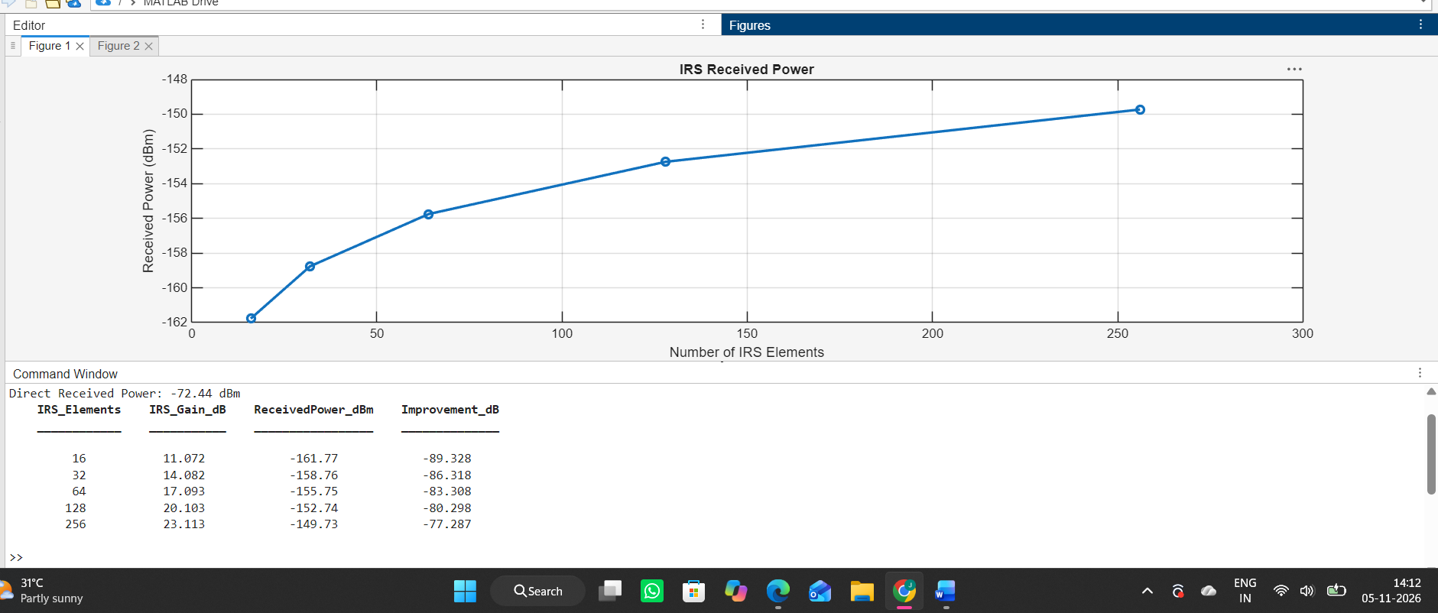
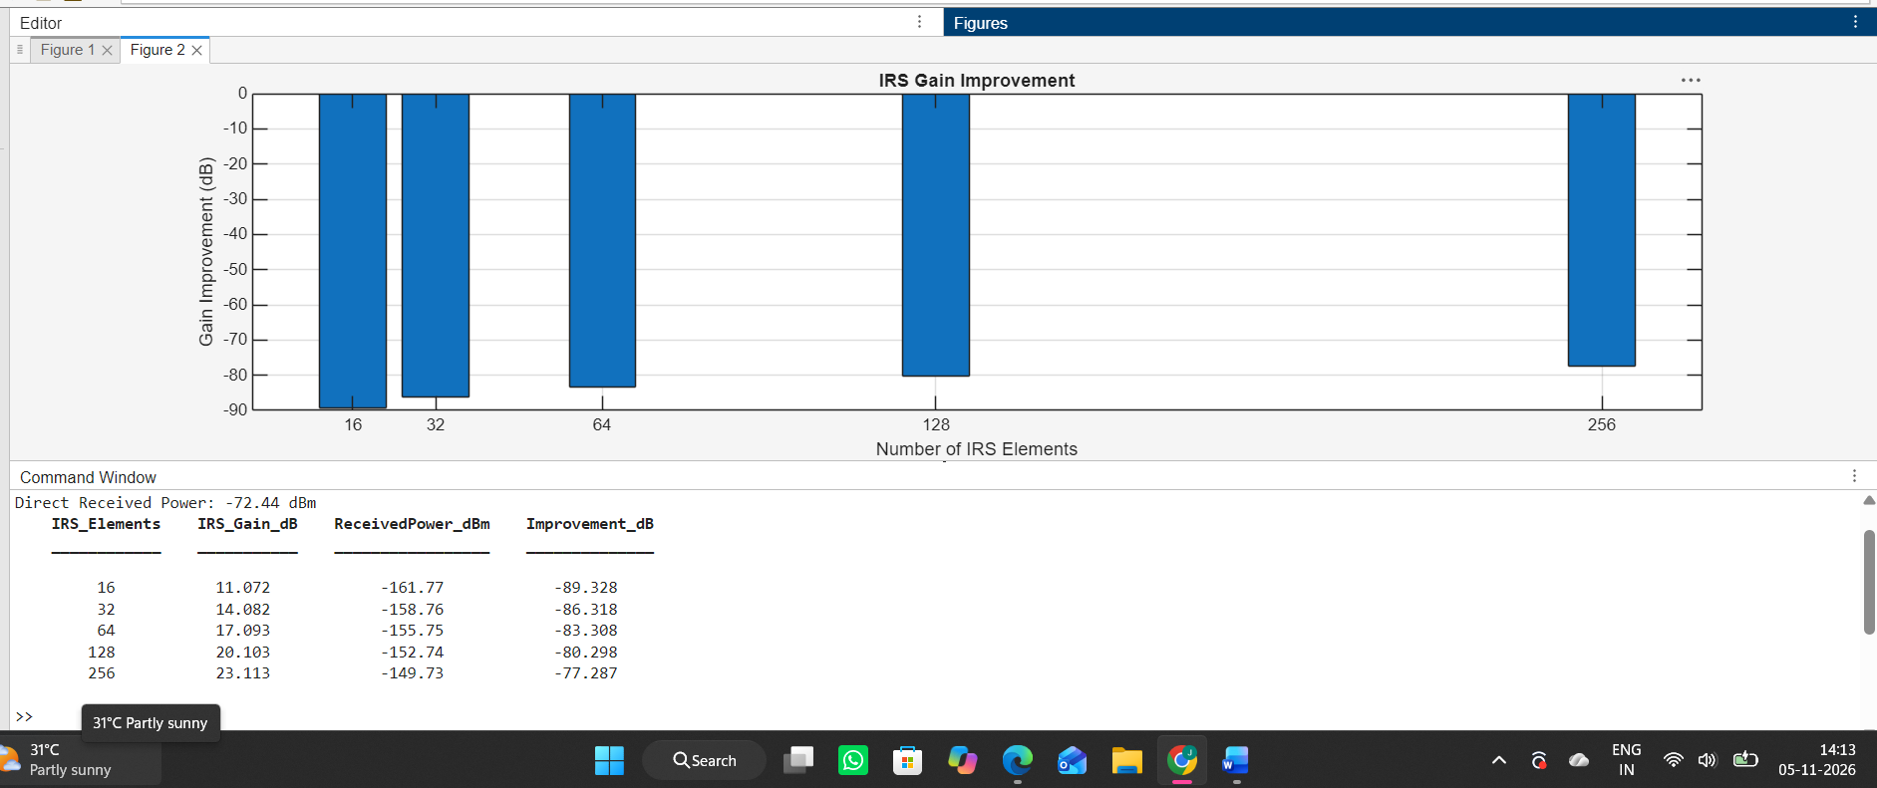

Result
The IRS-assisted 6G communication model was successfully simulated using MATLAB. Received power and gain improvement were calculated for different numbers of IRS elements. The model showed increasing estimated IRS gain as the number of reflecting elements increased.

